**Ideas** : <https://www.thebestdesigns.com/collections/beautiful-travel-tourism-websites/>

eg: <http://www.turnefferesort.com/>

**Resources** : Get location through GPS and google maps media,reviews  
https://developers.google.com/maps/documentation/javascript/places#place_details

URL shortener API : <https://developers.google.com/url-shortener/v1/getting_started>

**Main page  
TABS**

* Login\signup
* Support
* About us
* Privacy policy | site map | terms of use | ©Travelbook 2017 | [Terms & Conditions](http://reisvoyage.com.au/terms_and_conditions/) | [Privacy Policy](http://reisvoyage.com.au/privacy_policy/) | [Website by the](http://yokedesign.com.au/) Origin   
  at bottom of page like this site ,

<https://us-keepexploring.canada.travel/>

* Explore! {search for locations/people}
* Find explorers!
* Home
* Fb/Instagram/pinterest/twitter/snapchat/G+ page link icon
* Logo for TravelBook

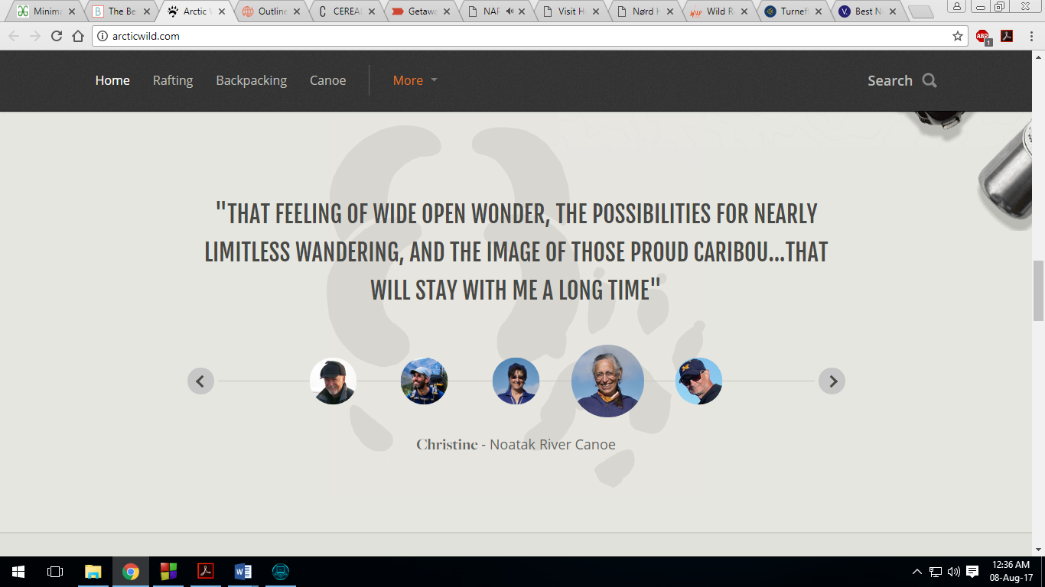

TESTIMONIAL

**DETAILS/CONTENT**

* If logged in, login/signup tab should display circular crop photo of user.
* Show a quote or slogan eg: *“travel book-explore better”* and travel quotes by famous people.
* IF USER **ALLOWS** TO SHARE LOCATION : Show current location of user on map, location name and current weather and display nearby tourist attractions as carousel, carousel would have picture, description with read more…, instagram photos, of nearby places.
* Add parallax like this site if feasible : <http://outlines.pt/>
* Recent posts column of photos, videos, blogs will be displayed.
* Add traveler tips eg : pickpocketing warnings.

**TAB DETAILS :**

**1)Login/signup tab:**

**Sign-up fields** : name, username, age, gender, email, DP, description, country, state, city*. “I agree with the use of my personal data?”,* Email verification for account, don’t allow illegal characters to be input. Add Submit and reset buttons.

**Login-field**: ask email/username and password for login, keep forgot password option, if user enters incorrect password 5 times, lock account and send new password in email. Password must contain min 8 characters, with numbers and capital & small case letters and a special character. add captcha for login.

After login, **Login/signup tab** must be renamed as **My-Account** tab and show circular cropped user DP in that tab. And show new tab **notifications,** next to it**.**

**My-Account** **tab:** allow user to edit information like, DP ,Name, Username, Age, gender, description, country, state, city. And add new information like user-status(like FB status), active-chat-sessions, number of posts, photos, videos, blogs created by the user, also mention follower count and names of that user’s followers and also people the user follows and their count, show personal messages sent by other users.

**Notifications tab:** show if friend request is accepted by someone, important notices, media

upload/interact timeline. If a friend request sent to you by someone else, then show message “do you want to add as friend? With add button” on adding, friends list must update for both the users.

**2) Home:** redirect to home page of app

**3)explore! :** on clicking it, new page will open, drop down menu will open with 3 tabs**, places near me, discover new places, I’m feeling lucky**

* **Places near me**: clicking it, will ask for user location info if not already provided and open a new page showing user location on a map, show the location name, with all tourist attractions near the user’s location which will also be highlighted on the map.
* **Discover new places**: user will search for a place, mention auto suggestions as user is still typing the location, if user clicks it to learn about that place.
* **I’m feeling lucky:** random place of attraction anywhere.

**4)Find explorers! :** entering a name will show all users with that name with their DP and status, mention auto suggestions as user is still typing the user name/name. Clicking the users will open their profile page.

**5) Support-**clicking it will drop-down 3 tabs**, contact us, FAQ, Complaints**

* **Contact us :**  open new window, “send us a message, enter fields name, email, description, send message button”. At page bottom show fb, instagram, snapchat, pinterest icons.
* **FAQ :** frequently asked questions.
* **Complaints** :open new window, “name , email, description, select topic best representing your problem{bug in website, error in information, bad website response, feedback, suggestions, others}” . allow attaching image for complaint. Use captcha before sending complaint. Submit and reset buttons.

**6) About us :** open new page to show logo, motto, app description, company description, founding members as carousel, and testimonials as carousel

**EVENT/OBJECT DETAILS :**

1. **LOCATION** :

When user selects a location by clicking It, the location info loads in a new tab, display location name, location mark on a map. Weather in that location, description of that place, **a 5 star rating system** for that location which only a logged in user can rate. The **media** related to that location will also be displayed (photos, videos, blogs) , it will also feature 360 degree street view if it exists for that location, each media can be commented/rated by all users excepted the one who uploaded that media, each media will also show which user has uploaded them and he dates when they were uploaded. There will be **a location-alert button**, on clicking the button any disasters/problems existing in that place will be mailed/notifications/sms be sent to users, on clicking the button again it should unsubscribe, also the mails/notifications/sms must have the text “do you want to unsubscribe for alerts for this location?” **if chatroom already exists** for that location, then a logged in user can enter the chatroom. If chatroom doesn’t exist, a logged in user can create a new chatroom for that location. Each location is to be treated as object. Each location must have number of views for that page. On the location page there is **Upload** button for logged-in users for them to upload media like photos, videos, blogs for that location.  
**GPS Location tracking** : For children and senior citizens(take their age), an option will be displayed *“Do you want to enable GPS location tracking for you?”* if **yes** then , ask them *date*, *start* and *end*-*time* between which to track the user, then the user will be asked “*Please enter the list of email-ids o which your GPS co-ordinates co-ordinates will be mailed every 15 minutes( allow user to change this time interval)”,* after entering the email-ids, those emails will be updated every 15 mins by sending them the user’s GPS co-ordinates.

**NOTE** : *if location information unavailable then use google locations APIS to get location info and media,  
 Non-logged in users can’t use rating system, location-alert button, chatroom functions.*

1. **USER PROFILE :** On visiting a user’s profile, their name, age, gender, username, status, description , country, state, city, active-chat-sessions(on clicking this, user is directed to that chatroom page and is asked whether to join that chat), number of posts, photos, videos, blogs created by that user, also mention followers count , also show people the user follows and their count, based on the stars the user got on his media the average of all star ratings will appear on his profile. user can Follow the user by clicking “**Follow button**”. User can send **friend request** to user. If a user de-activates their account, everything about the user should be deleted and it must be updated in the followers/friends list of other users too. If the user is already a friend , he can send a message to the user which will appear in the notifications of that user. Users can **unfollow**, and **unfriend** them. Show timeline of that user’s activity.   
   **NOTE** *: If 2 users are friends then they automatically become followers., similarly if unfriended then unfollow them too, If the user is already a friend then the profile should mention “This user is your friend”.*
2. **CHAT ROOM :** Each chatroom will be **auto-deleted** if there is no activity for 5 days period, chatroom facility requires **login**, can only send text message in chat, once a user enters chatroom, he can see chat history since the chatroom was created, set limit for number of people able to join any chatroom, users can **reply to a specific comment** like whatsapp’s reply feature, show time and date of each message along with the user name of that message, clicking **username** must redirect to his/her profile. Set **limit** on number of characters user can enter in chat like max limit 255 characters in twitter. User can see all participants in that chatroom. Treat chatroom as an object. User can exit chatroom whenever he wants.

\***NOTE** *: It is possible that 2 users can create a chatroom for same location at same time, so once a chatroom is created it must first check if already created else it must update quickly in server so the other user can’t create duplicate chatroom\**

1. **MEDIA :** Each media video, photo, blog will be treated as on object. Each media has a rating out of 5 stars which all users except the user who uploaded it can rate it. When user clicks rating stars multiple times , the rating given by him the latest will be considered. Each media element will have a sharable link shortened by google URL shortener API so he can share that media with someone. Users can comment on the media. Each media will have mention of which user uploaded it.